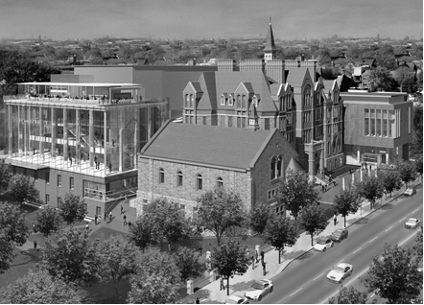
The Lois Birkenshaw-Fleming
Creative Teaching Scholarship
Application Form
Fax OR email completed application and transcript of grades from
Intro, Level I and/or Level II, or other courses to:
Steven Foster, Room 102
Fax: 416-408-3096; Email steven.foster@rcmusic.ca
Application Deadline (spring): Mar 10, 2017, noon
Application Deadline (summer): June 1, 2017, noon
Late, incomplete applications, OR non-use of this Application Form WILL result
in the candidate’s disqualification

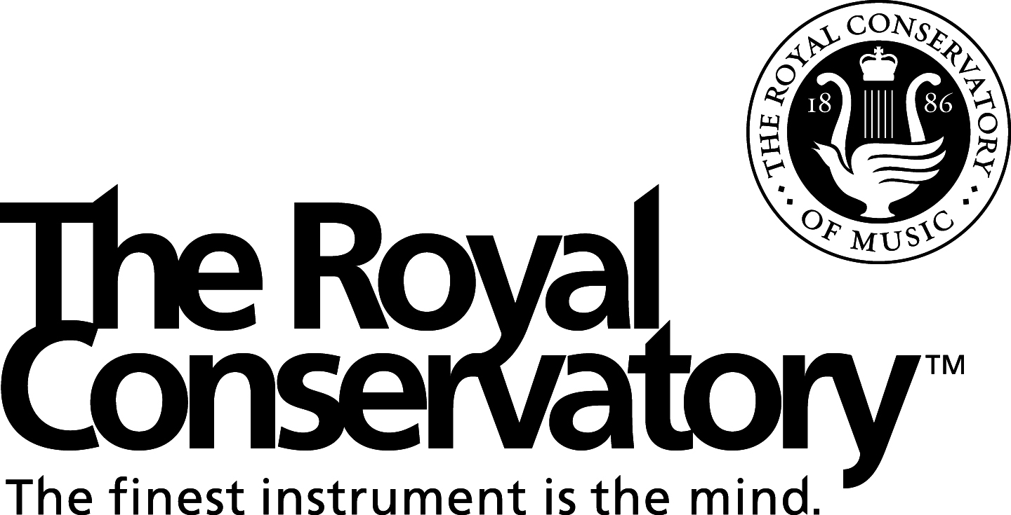

ELIGIBILITY
Scholarship applicant must be registered for one of the following Royal Conservatory Courses:

Introduction to Orff
Orff Pedagogy Level I
Orff Pedagogy Level II
Orff Pedagogy Level III
Music from Five Continents (full course)
Music in Early Childhood

APPLICATION DEADLINE
Spring applications are due by noon on March 10, 2017
Summer applications are due by noon on June 1, 2017

Fax or scan/email completed application, letters of reference and transcript of grades from music pedagogy courses you have taken to:

The Royal Conservatory
Attention: Steven Foster, Room 102
Fax # 416-408-3096
steven.foster@rcmusic.ca

APPLICATION PACKAGE
Completed application
Letters of reference
Transcript of grades if applicable
Late, incomplete applications OR non-use of this Application Form WILL result in the candidate’s disqualification. We will not contact applicants for missing information.

REFERENCES
Applicants must provide two letters of reference, one from an education specialist or a music/arts consultant/supervisor and the other from a previous instructor, where possible. Your referees should be able to attest to your abilities and potential as a music teacher for children. It is the applicant’s responsibility to ensure that the letters of reference are submitted with the completed application form before the deadline.

LOIS BIRKENSHAW-FLEMING
CREATIVE TEACHING
SCHOLARSHIP APPLICATION FORM

Name: ______________________________________________________________
Address: ______________________________________________________________
______________________________________________________________
City Province Postal Code
____________________________________________________________________
Daytime Phone # Evening Phone #
____________________________________________________________________
Email Address

Applicant must be registering for one of the following Royal Conservatory courses.
Please check one:
□ Introduction to Orff □ Orff Level I □ Orff Level II □ Orff Level III
□ Music from Five Continents □ Music in Early Childhood

List educational institutions attended and degree(s)/certificates obtained beginning with
most recent
__________________________________________________________________________
__________________________________________________________________________
__________________________________________________________________________
__________________________________________________________________________

Please list any additional professional development not covered above you have undertaken in music pedagogy (attach certificate copies or transcripts where applicable), for example, a Post Level III Orff Course sponsored by an Orff Chapter.
__________________________________________________________________________
__________________________________________________________________________
__________________________________________________________________________
__________________________________________________________________________

Please attach a detailed statement expressing your interest in and experience of a creative approach to teaching.

